**Installing XAMPP and MySQL database for Online Car Rental Project:**

There are a few local servers you can download and some of them are XAMPP, WAMPP etc. We are using XAMPP server. With this we get Apache server and MySql database.

Go to google and search for XAMPP download.

You will get many sources from where you can download XAMPP. The following is one of them.

<https://xampp-windows.en.softonic.com/download>

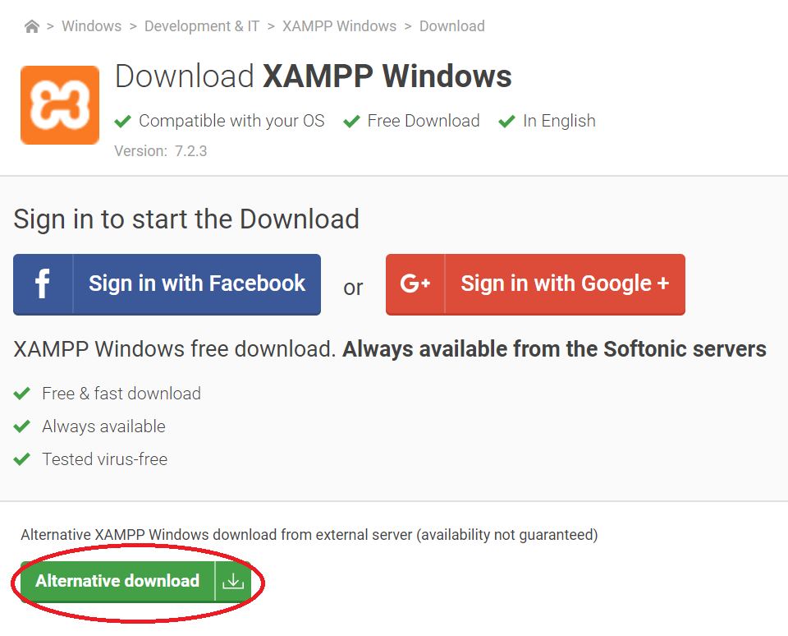

Once you download XAMPP, install it on your system.

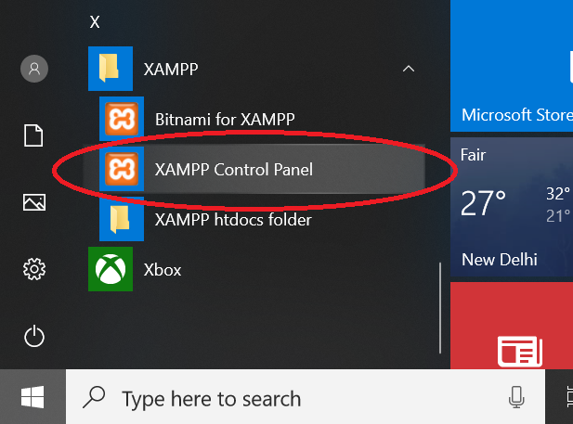

Once it is installed successfully, go to windows start button and go to folder XAMPP and you will see XAMPP Control Panel. Open the XAMPP control panel.

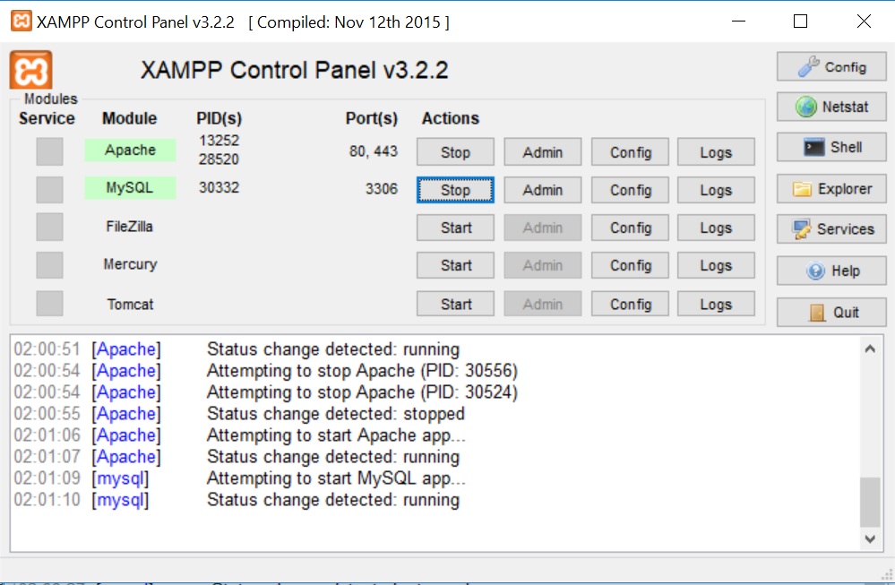

Start the Apache Server and MySQL server by clicking on start buttons. You should see that both are started without any errors.

Now you can access the database using the following url.

<http://localhost/phpmyadmin>

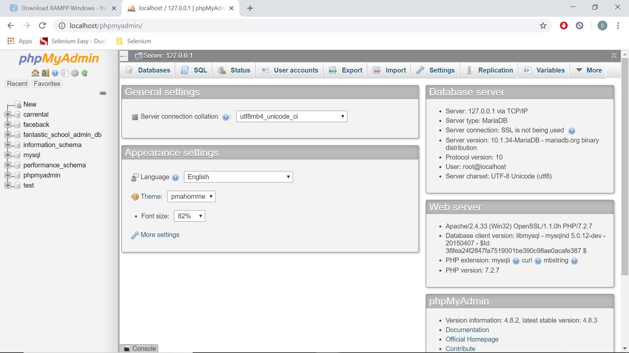

On the left-hand side, you will see different databases.

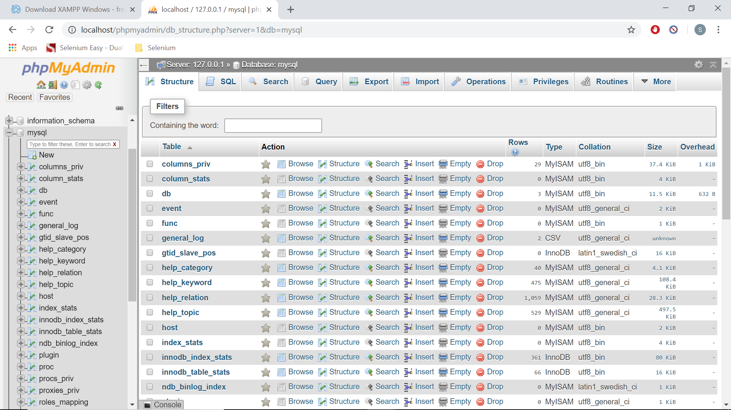

Once you click on any database, you will see the different tables associated with it.

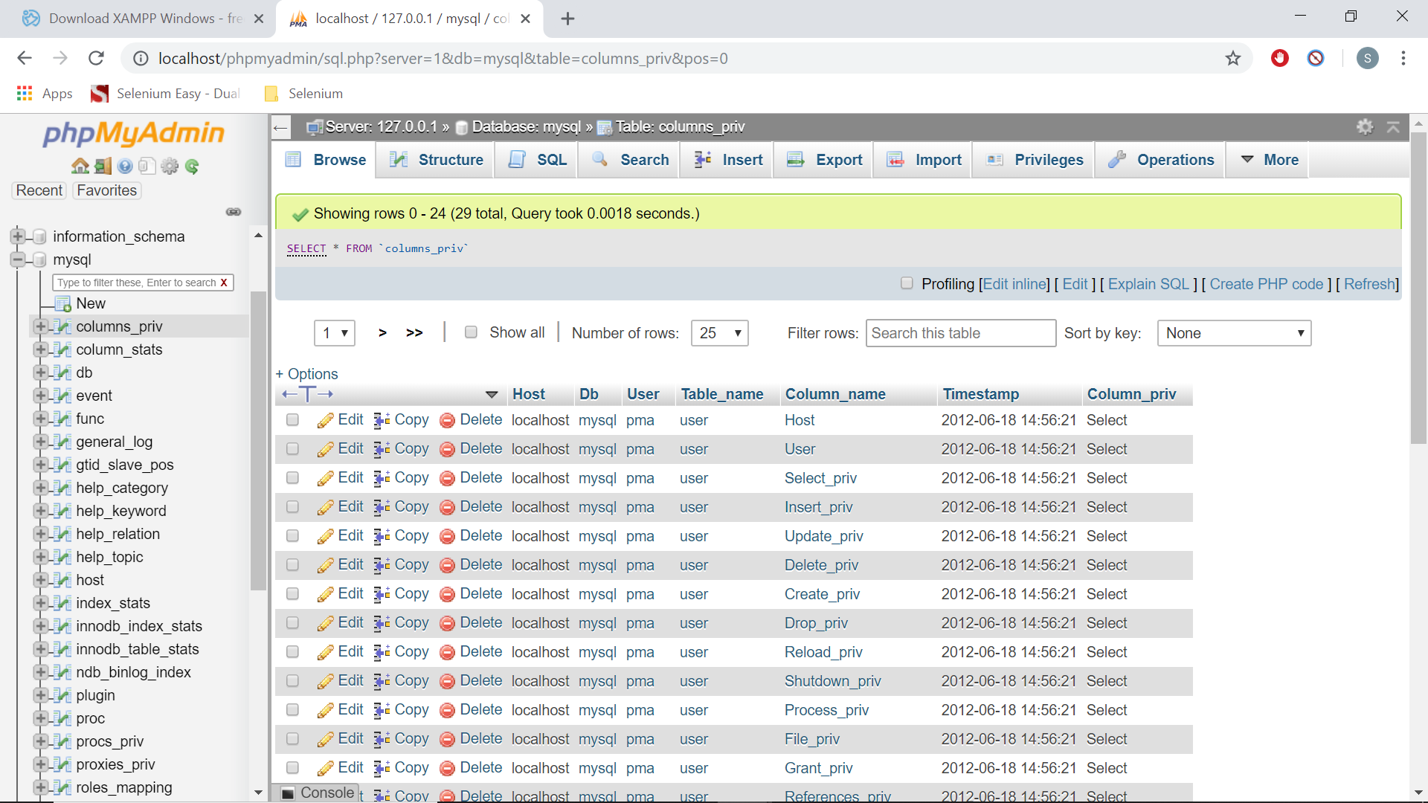

Once you click on any table you will see the data of the tables.

**Setting up a User Name and Password:**

Once you install XAMPP, the default user name and password for accessing the databases in phpMyAdmin are

User name: root

Password: (no password).

You can use the above details for connecting to any database using JDBC. But let’s create a new username and password.

Go to the home page by clicking on the home button or phpMyAdmin image on the top left side. Now click on “User Accounts” and you should be able to see all the user names here.

Click on “Add User Account” link.

Enter the user name and password you like.

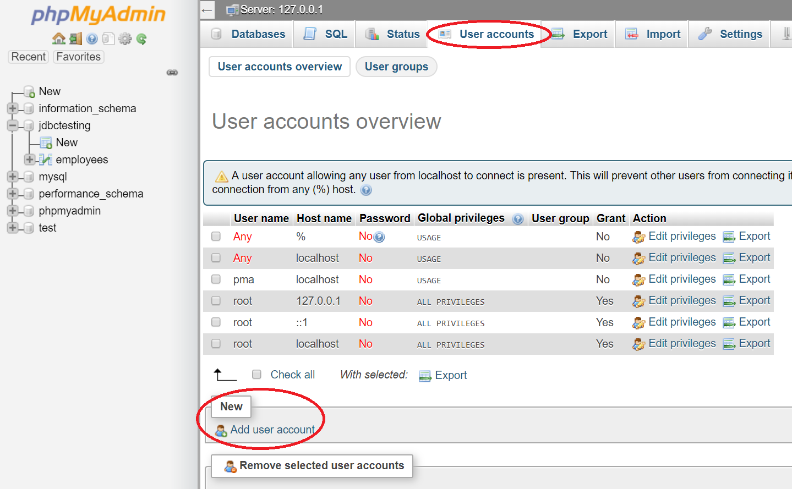

Enter the user name and password you like. (I am adding username: subbu123 and password: subbu123)

Select the host as localhost. (This is important otherwise it won’t work)

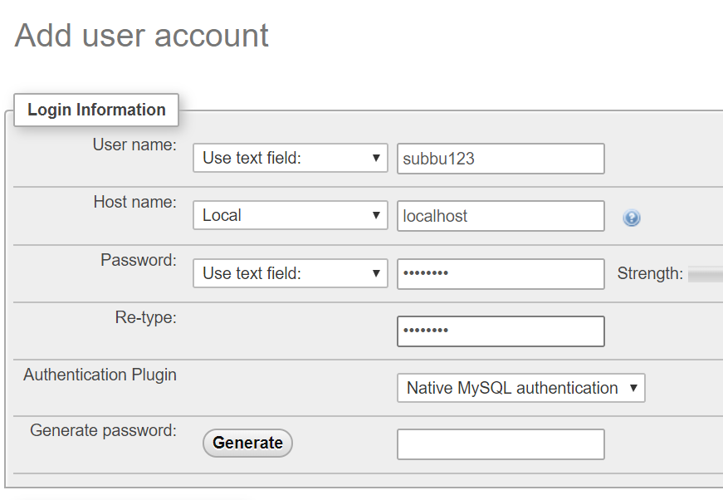

Under the Global Privileges section, select the checkbox “Check All” and save it and a new user should be created with all the privileges.

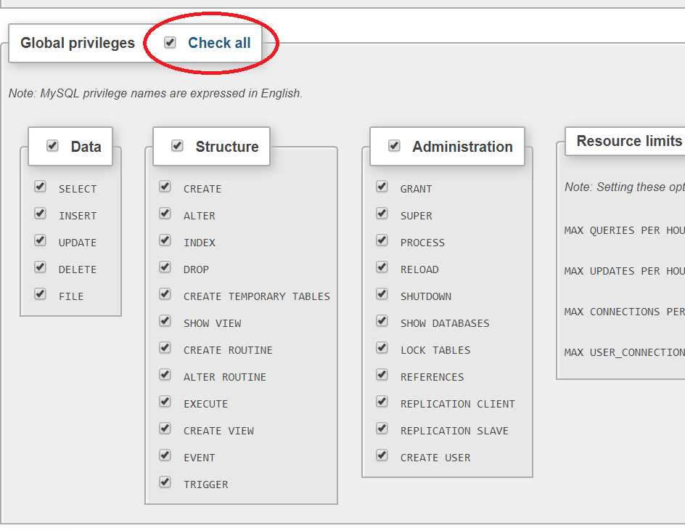

This step is important as if you don’t select this check box the new user will not get all the privileges.

**Setting up a site in our local host:**

The site we are setting up is an online car rental system. This is developed in php and you can download it for free at the following location.

<https://code-projects.org/online-car-rental-using-php-source-code/>

You don’t need to use the same system but you can use any system you want. If you can set up that system on your localhost, you can use that.

Now go to the XAMPP control panel and start the apache server and mysql.

Once you download the car rental system, go to the phpMyAdmin and create a new database “carrental”.

You will see a folder sqlfile in the downloaded project. It contains a sql file in this and run this file in the database and all the tables will be created.

We have already created a new user earlier with all the privileges. We will be using this user to update the configuration files in the project.

Now go to htdocs folder in your xampp folder created as part of the installation. In my case it is at the following location.

C:\xampp\htdocs

Put your carrental folder in this htdocs folder. This folder should contain the index.html file.

Now go to the car rental folder and you will see “includes” folder and there is a config file with in that folder. Update the file with the user details that we have created.

Now go to the Admin folder and you will another “includes” folder and there is another config file and update this file as well with the DB username and password we have created.

Now everything is set up.

If you go to the link <http://localhost/carrental> you should be able to see the homepage.

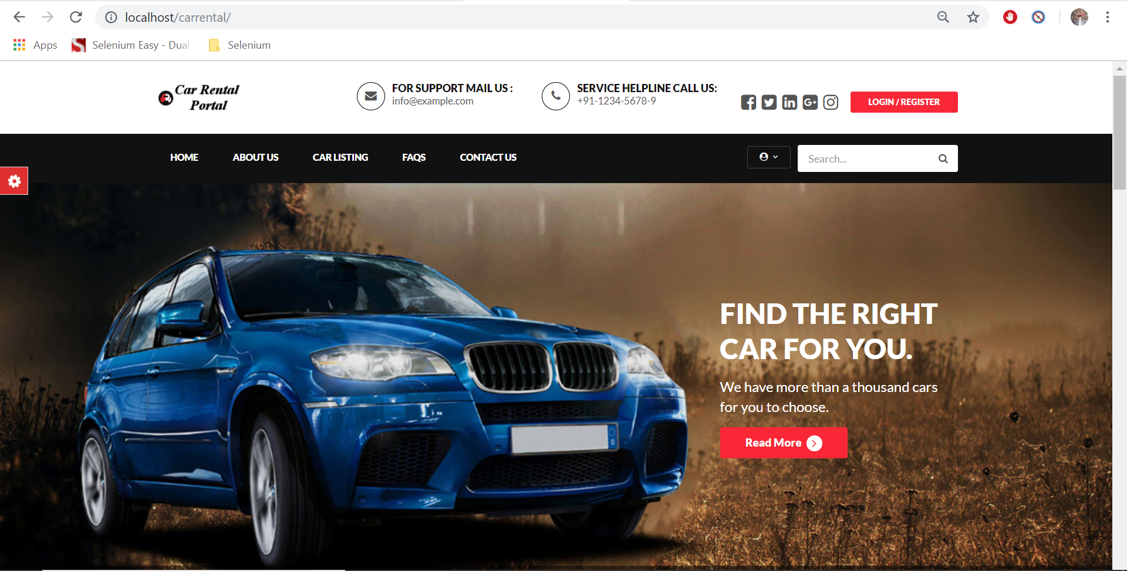

If you go to <http://localhost/carrental/admin> you should see the admin login page.

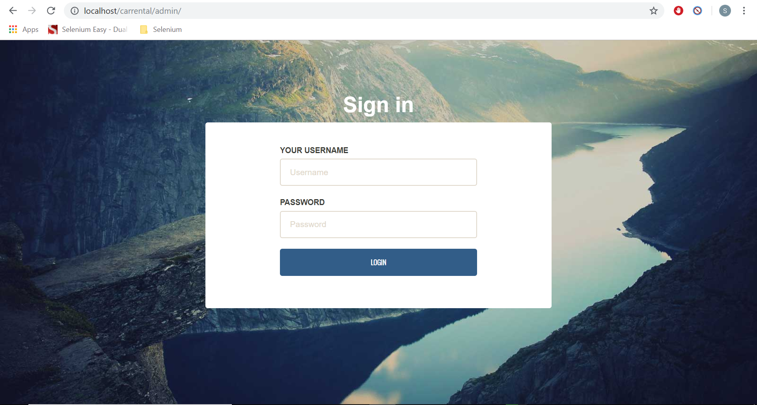

The default username and password for the admin are

Username: admin

Password: Test@12345

**Application Overview:**

Let’s have a look at the sample project that we have installed earlier. Because we are going to use the same project for automation and we will be using different frameworks to automate it. So, we have to know the application.

The project contains two modules.

1. Admin Module – http://localhost/carrental/admin
2. User Module – http://localhost/carrental

As an admin, you can do the following actions. First login into the application.

Dashboard: You can see the activities overview like no. of regist ered users, no. of listed vehicles, total no. of bookings etc., here.

Brands: You can manage brands and also can add new brands here.

Vehicles: You can manage vehicles and add new vehicles here.

Manage Booking: You can approve or reject bookings here.

Manage Testimonials: You can manage testimonials like make them active or inactive here.

Manage Contact Us Query: You can read the queries sent by people here.

Reg Users: You can view the registered users here

Manage Pages: You can change the pages on the website here.

Update Contact Info: You can update contact info here.

Manage Subscribers: You can manage the subscribers here. You can delete the subscribers.

As a user you can do the following things.

1. Navigate to different pages without logging.
2. Login and navigate to different pages.
3. You can change your settings under profile settings.
4. You can go to Car Listings and you can book a car.
5. You can go to update password and update your password.
6. You can go to My Booking and view your bookings.
7. You can go to Post a Testimonial and post your testimonial.
8. You can go to My Testimonial and view all your testimonials.
9. You can sign out.

So, this is all about the application that we are going to automate using different frameworks with selenium.